NAME: THEODAR SAMUEL. S
DEPARTMENT: B.E BIOMEDICAL ENGINEERING
COLLEGE: 8151- DHANALAKSHMI SRINIVASAN INSTITUTE OF TECHNOLOGY, SAMAYAPURAM, TRICHY
NAANMUDHALVAN COURSE: DIGITAL MARKETING
NM ID: BDA76BC1F151B24BCF24C660E9A6A3E2
NM TEAM ID: NM2023TMID02386

ASSIGNMENTS ON DIGITAL MARKETING
1. Create a Blog or Website using Blogspot and Wordpress. Customize the theme design and post new articlre with 500 words.
Blogspot URL:
https://melangerr.blogspot.com/2023/08/exploring-remarkable-innovations-mini.html?m=1
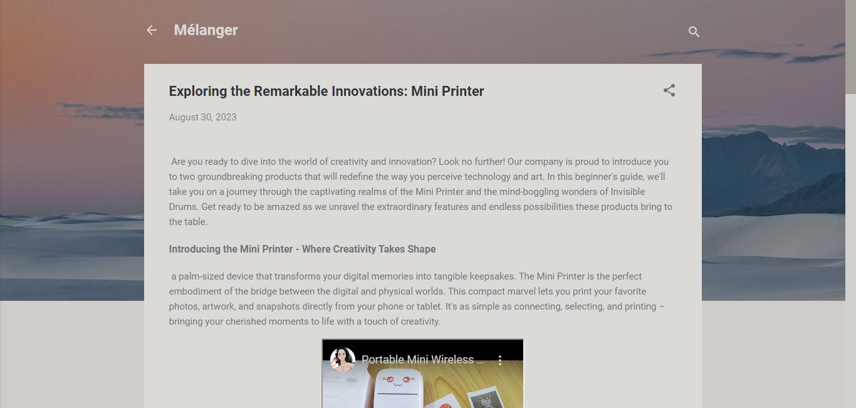

Wordpress URL:
https://melanger0.wordpress.com/2023/08/30/exploring-the-remarkable-innovations-mini-printer/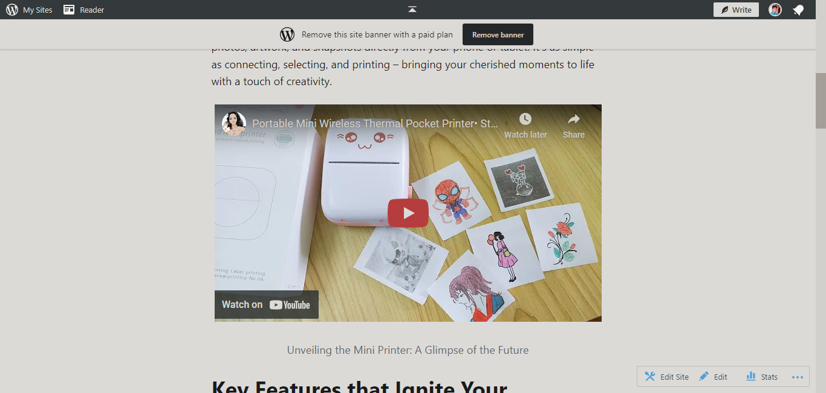

2.Create a New Facebook Business Page and Post One Social Media Poster for your brand.

www.facebook.com/meLanGErR
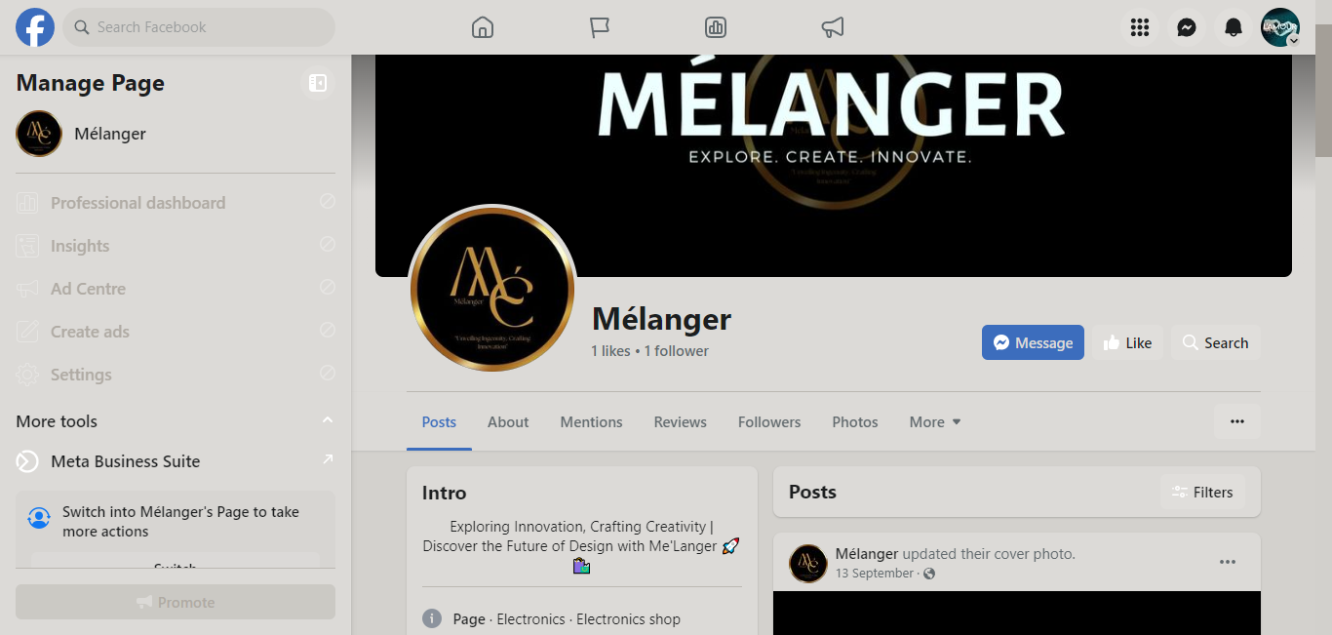
3.Create and design a social media advertisement poster using canva.

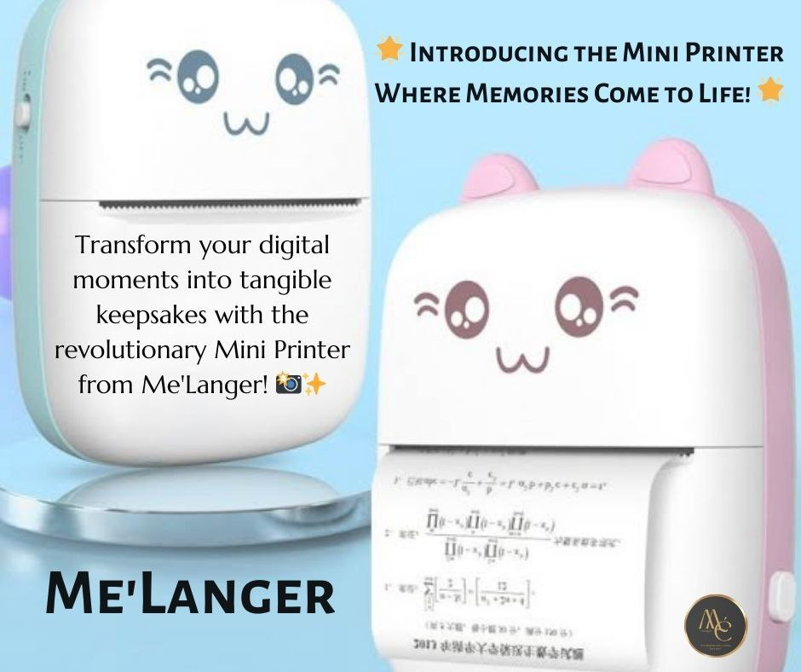

4. Create email news letter design using Canva or mail chimp.
